Networking Training
Allen Paul - Assignment

Module 5 and 6:

Problem 1:
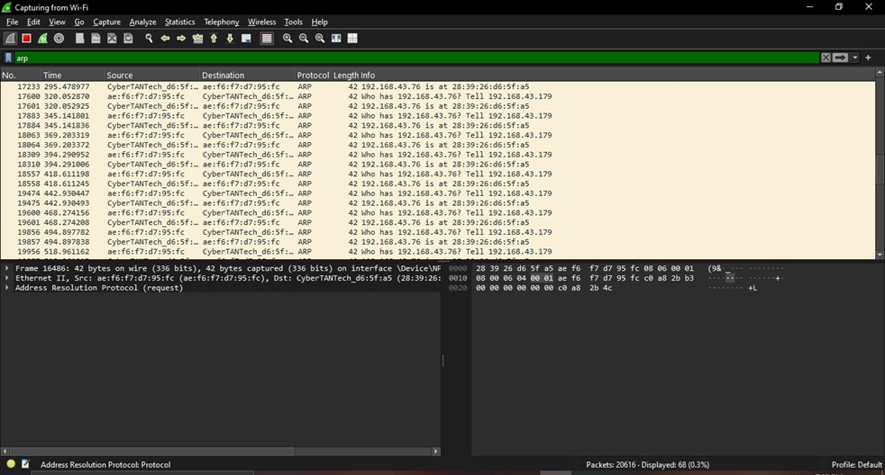

The sender's MAC address (ae:f6:f7:d7:95:fc) belongs to the device making the ARP request. The sender's IP address (192.168.43.179) indicates the device that is looking for the
MAC address of 192.168.43.76.
The target MAC address is 00:00:00:00:00:00 because the sender does not yet know it.

The target IP address is 192.168.43.76, meaning the sender wants to communicate with this device.
The ARP request is broadcasted to all devices on the local network to resolve the MAC address of 192.168.43.76.
If 192.168.43.76 is active, it will reply with an ARP reply containing its MAC address.

Once the ARP reply is received, 192.168.43.179 can directly communicate with 192.168.43.76 using its MAC address.
This process enables devices in a local network to discover each other's MAC addresses for direct communication.

Problem2:

ARP spoofing is an attack where a malicious device sends fake ARP replies on a network. The attacker associates their MAC address with the IP of a legitimate device,
like the gateway. Victim devices update their ARP cache with the attacker's
MAC instead of the real one.
Traffic meant for the legitimate device is sent to the attacker instead.

The attacker can intercept, modify, or drop packets (Man-in-the-Middle attack).

Problem3:
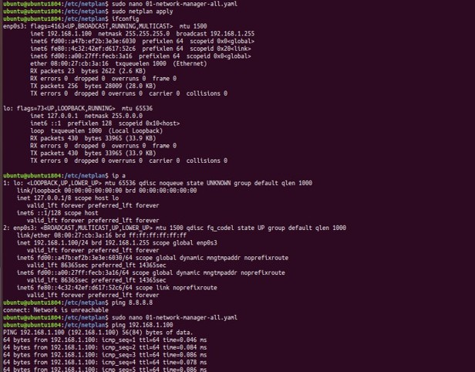

As here in VM only Ethernet interface is available and I am connected to wifi, so I just ping locally the static ip and shown results.

Problem 4:
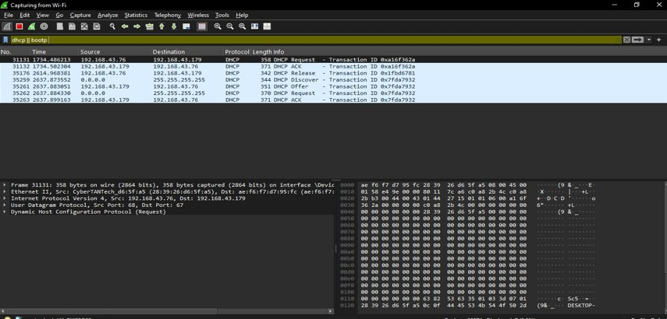

The client, without an IP, sends a DHCP Discover message as a broadcast (0.0.0.0
→ 255.255.255.255), asking for an IP address.

The DHCP server (192.168.43.179) responds with a DHCP Offer, offering an available IP (192.168.43.76) along with subnet mask, gateway, and DNS info.
The client sends a DHCP Request, confirming it wants to use the offered IP, broadcasting this request so other DHCP servers know it has made a choice.
The DHCP server sends a DHCP Acknowledge (ACK) to finalize the process, officially assigning 192.168.43.76 to the client with lease and configuration details.
The client can now communicate on the network using the assigned IP. If multiple DHCP servers reply, the client selects one and ignores others.
If no DHCP server is available, the client may assign itself an APIPA (169.254.X.X). This process is essential for automatic IP assignment.

Problem 5:

Subnet 1:

Network: 192.168.1.0/26 First usable: 192.168.1.1 Last usable: 192.168.1.62 Broadcast: 192.168.1.63
Subnet 2:

Network: 192.168.1.64/26 First usable: 192.168.1.65 Last usable: 192.168.1.126 Broadcast: 192.168.1.127
Subnet 3:

Network: 192.168.1.128/26 First usable: 192.168.1.129 Last usable: 192.168.1.190 Broadcast: 192.168.1.191
Subnet 4:

Network: 192.168.1.192/26 First usable: 192.168.1.193 Last usable: 192.168.1.254 Broadcast: 192.168.1.255

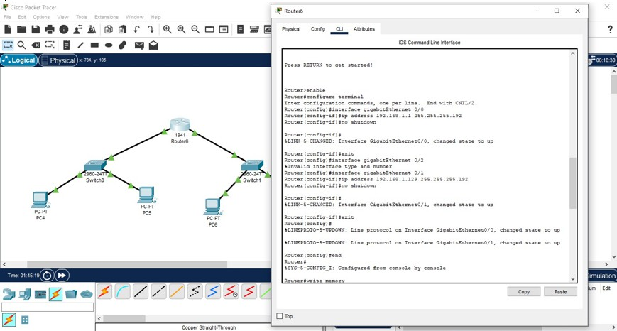

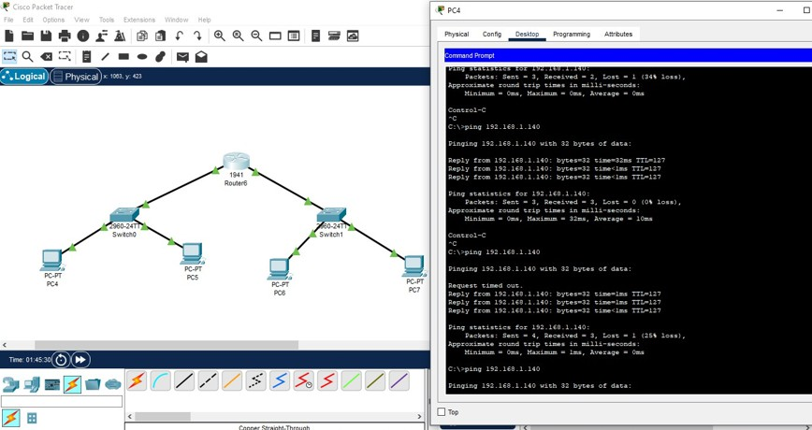

Problem 6:

IP Address:
10.1.1.1
Class: A
Default Subnet Mask: 255.0.0.0

Class A Range: 10.0.0.0 - 10.255.255.255

First Octet Range: 1 - 126

IP Address: 172.16.5.10

Class: B

Default Subnet Mask: 255.255.0.0

Class B Range: 172.16.0.0 - 172.31.255.255

First Octet Range: 128 - 191

IP Address: 192.168.1.5

Class: C

Default Subnet Mask: 255.255.255.0

Class C Range: 192.168.0.0 - 192.168.255.255

First Octet Range: 192 - 223

Problem 7:
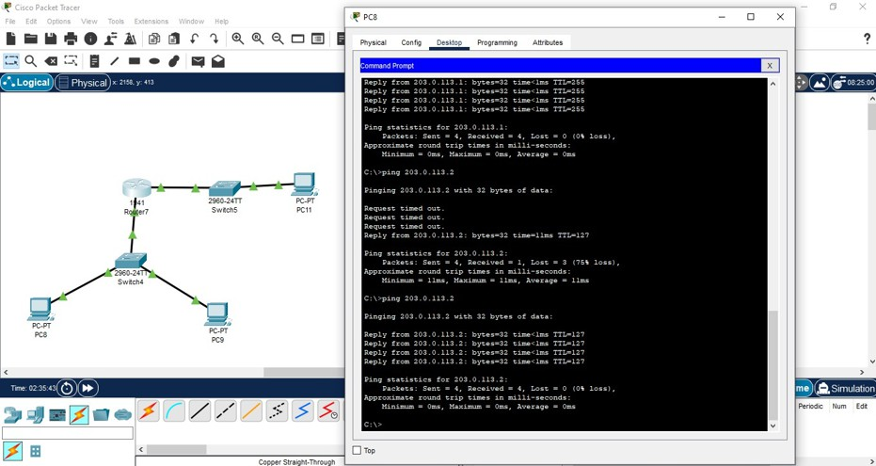

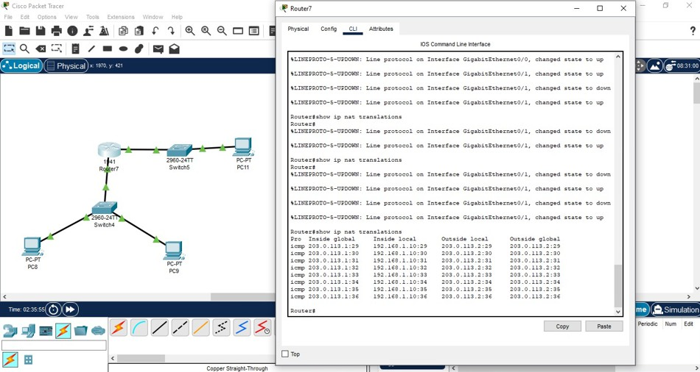

Before NAT:

Source IP in the packet is 192.168.1.10 (Private IP). Router performs NAT and replaces the source IP. After NAT:
Source IP becomes 203.0.113.1 (Public IP of the router). Packet reaches the destination 203.0.113.2.
Response from 203.0.113.2 is sent back to 203.0.113.1.

Router translates it back to 192.168.1.10 and forwards it to the PC. PC receives the response, completing the communication.

Problem 8:
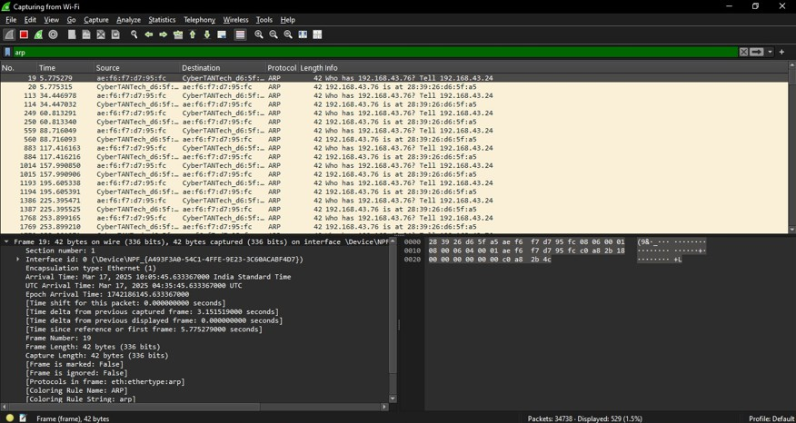

Translates IP addresses to MAC addresses for communication within a local network. Enables devices to find each other on the same subnet by resolving unknown
MAC addresses. Allows communication with the router by finding the MAC
address of the default gateway.

Essential for Ethernet-based networks, where frames require destination MAC addresses. Facilitates packet delivery within a LAN before forwarding to external networks.
Maintains an ARP cache to reduce repeated requests and improve efficiency.

Problem 10:

Dividing into 4 equal subnets:

New subnet mask: /26 (255.255.255.192) Each

subnet has 64 addresses (2^6
= 64)
Valid host range (excluding network & broadcast addresses): Subnet 1:
Network: 10.0.0.0/26
Valid hosts: 10.0.0.1 – 10.0.0.62
Broadcast: 10.0.0.63

Subnet 2:
Network: 10.0.0.64/26
Valid hosts: 10.0.0.65 – 10.0.0.126
Broadcast: 10.0.0.12

Subnet 3:
Network: 10.0.0.128/26
Valid hosts: 10.0.0.129 – 10.0.0.190
Broadcast: 10.0.0.191

Subnet 4:
Network: 10.0.0.192/26
Valid hosts: 10.0.0.193 – 10.0.0.254
Broadcast: 10.0.0.255
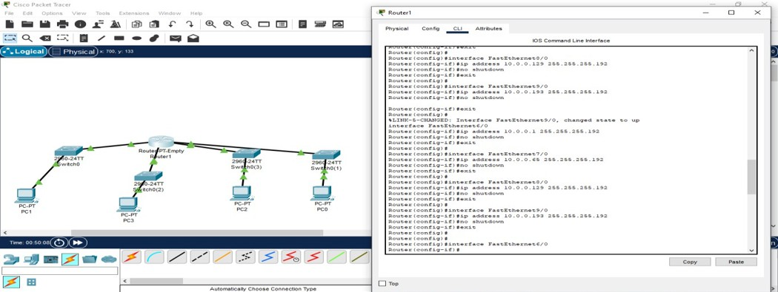

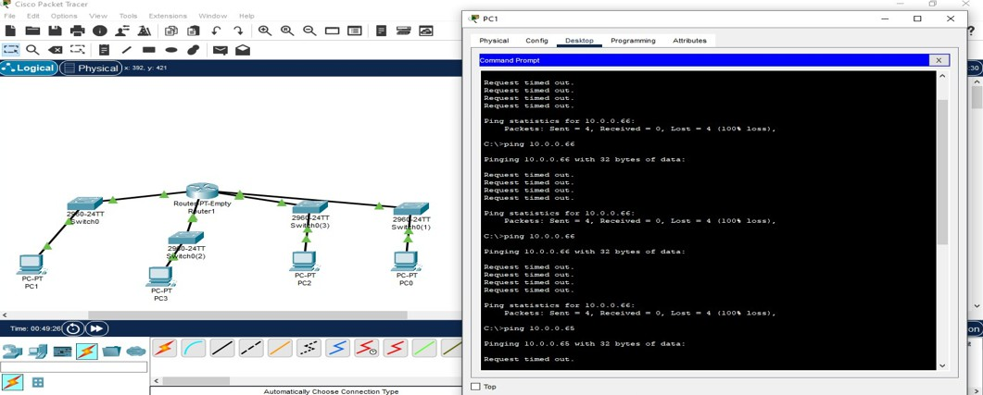

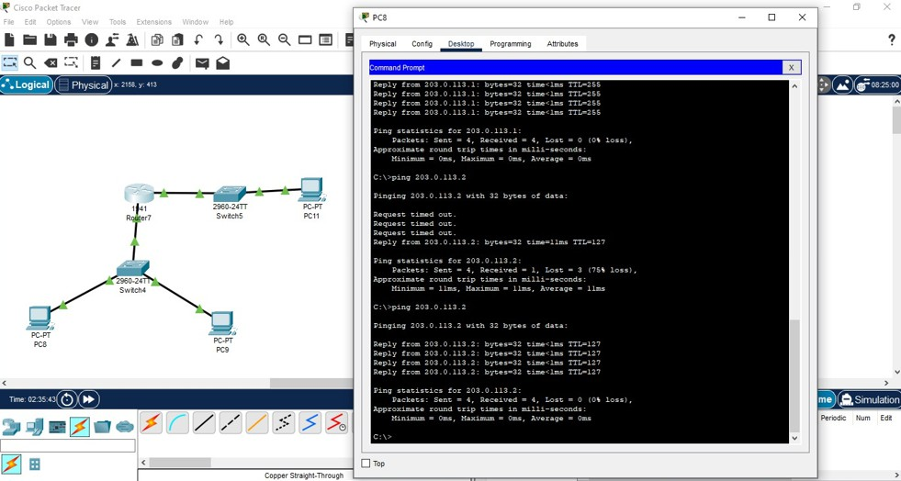

Problem 11:

- 192.168.10.5

- Class C (Range: 192.0.0.0 – 223.255.255.255)

- Private (192.168.x.x is reserved for private networks)

- 172.20.15.1

- Class B (Range: 128.0.0.0 – 191.255.255.255)

- Private (172.16.0.0 – 172.31.255.255 is reserved for private use)

- 8.8.8.8

- Class A (Range: 1.0.0.0 – 126.255.255.255)

- Public (Google’s public DNS server)

Problem 12:
